Name _____________________________________ Date _________________________

Review for Probability Test

I am ready for the test because I can…
- Describe the probability of an event.
- Find the theoretical probability of an event.
- Find the complement of an event.
- Find the experimental probability of an event.
- Use proportions to make predictions.
- Find the sample space by drawing a tree diagram.
- Find the sample space by listing all possible outcomes.
- Use the counting principle to state the number of possible combinations.
- Find the probability of multiple events with replacement.
- Find the probability of multiple events without replacement.

Directions: Find the probability of the following events as a fraction.

- There are 12 sixth graders, 11 seventh graders, and 9 eighth graders in a gym class. The gym teacher randomly selects one student to collect balls. What is the probability that the gym teacher will choose a seventh grader?

- There are 7 sixth graders, 13 seventh graders, and 15 eighth graders in a gym class. The gym teacher randomly selects one student to collect balls. What is the probability that the gym teacher will choose a sixth grader?

- There are 16 sixth graders, 14 seventh graders, and 7 eighth graders in a gym class. The gym teacher randomly selects one student to collect balls. What is the probability that the gym teacher will not choose a seventh grader?

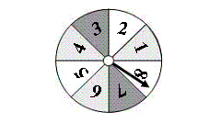
Directions: Use the spinner to determine the theoretical probability of the event.
- Spinning a 2 __________________________

- Spinning a 6 __________________________

- Not spinning a 4 _______________________

- Spinning a number less than 7___________

Directions: The bar graph shows the results of spinning the spinner 40 times. Find the experimental probability of the event.

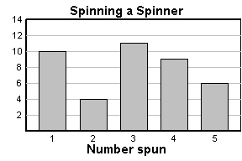
- Spinning a 3 ___________________________

- Spinning a number greater than 4________

- Spinning a number less than 5 ___________

- Spinning a 3 or a 4 _____________________

Directions: Use a tree diagram to find the total number of possible outcomes.
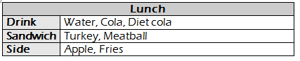

Directions: Make a list to find the total number of possible outcomes.
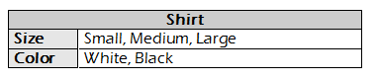

Directions: Use the Fundamental Counting Principle to find the total number of possible outcomes.
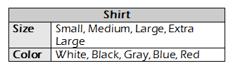
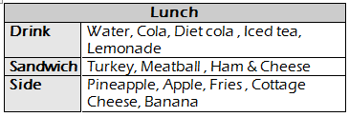
- 15.

Directions: You randomly choose one of the chips. After replacing the first chip, you choose a second chip. Find the probability of choosing the first chip, then the second chip.

- P(White and Red) __________________________________

- P(Green and Red) __________________________________

- P(White and Blue) __________________________________

- P(White and White) __________________________________

Directions: You randomly choose one of the chips. Without replacing the first chip, you choose a second chip. Find the probability of choosing the first chip, then the second chip.

- P(White and Red) __________________________________

- P(Green and Red) __________________________________

- P(White and Blue) __________________________________

- P(White and White) __________________________________

Directions: Describe the likelihood of the following events.
- The probability of having a boy. ______________________________________________________

- The probability of rolling a 7 on a number cube. ________________________________________

- The probability of a coin landing on heads or tails when flipped. ___________________________

- The probability of the Jets winning the Super Bowl. ______________________________________

- The probability of Mrs. Cress giving homework. _________________________________________

