Name __________________________________ Date _________________________

Homework #101 – Perimeter and Area of Polygons

Directions: Find the area and perimeter of the following figures by using an equation and solving algebraically.

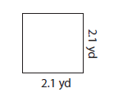
1) Perimeter = _________________
Area = _____________________

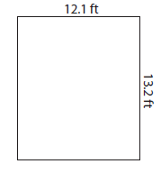
2) Perimeter = _________________
Area = _____________________

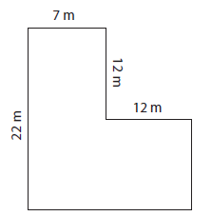
3) Perimeter = _________________
Area = _____________________

Directions: Find the area of the following figures by using an equation and solving algebraically.
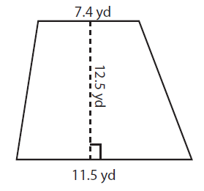
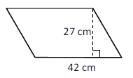
4) 5)

Directions: Find the missing side of the following figures by using an equation and solving algebraically.
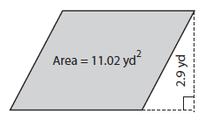
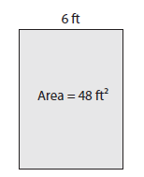
6) 7)

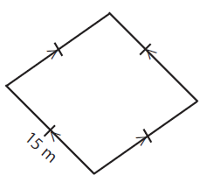
Directions: Find the perimeter of the following figures by using the properties illustrated. Make sure to state an equation and solve algebraically.

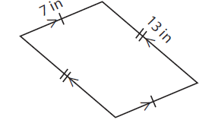
8) 9)

