Name ___________________________________ Date ____________________________

Homework #81 – Compound Events

Directions: Use the Fundamental Counting Principle to find the total number of possible outcomes.

- 2)
Photos
Size | Wallet, 4 by 6, 5 by 7,  8 by 10, 11 by 14, 16 by 20
Finish | Matte, Glossy
Edits | Red eye, Black and white, Crop

Laptops
Hard Drive | 250 GB, 320 GB, 500 GB
Style | HD, LCD
Color | Black, White, Red, Blue, Pink, Green, Purple

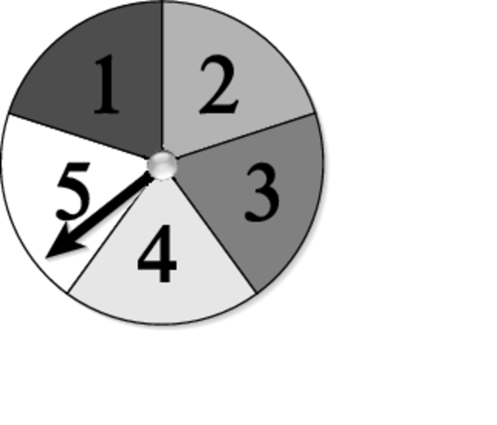
Directions: You spin the spinner and flip a coin.
- Use a table of tree diagram to find the sample space.

- P(Spinning a 2 and flipping tails)

- P(Spinning a 7 and flipping heads)

- Not spinning a 4 and flipping tails

