Name ___________________________________ Date ____________________________

Lesson #81 – Compound Events

The set of all possible outcomes of one or more events is called the ______________________________. You can use tables and tree diagrams to find the sample space of events.

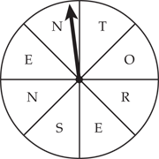
- List all of the outcomes when spinning the given spinner. How many possible outcomes are there?

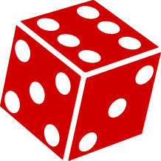
- Draw a tree diagram showing all the possible outcomes when rolling a number cube. How many possible outcomes are there?

- Draw a tree diagram showing all of the possible outcomes when flipping a quarter and flipping a nickel. How many possible outcomes are there?
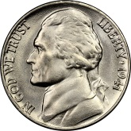

- You randomly choose a crust and style of pizza. Find the sample space by drawing a tree diagram. How many different pizzas are possible?
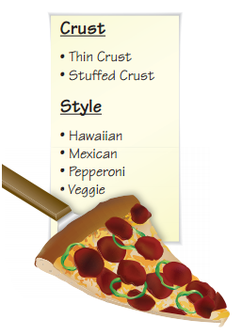

- The pizza shop adds a deep dish crust. Find the sample space by listing the possible outcomes. How many pizzas are possible?

Another way to find the total number of possible outcomes is to use the _________________________
___________________________________.

- The pizza shop now has 3 choices for the crust, 4 styles of pizza and 2 different types of dough. How man possible combinations are possible?

- Find the sample space of rolling a number cube and flipping a coin. How many possible combinations are there?

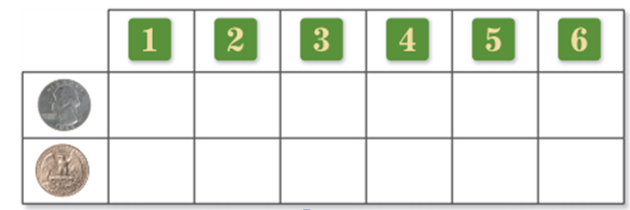

- Identify the number of possible outcomes of rolling a number cube and flipping a coin. Use the Fundamental Counting Principle to state the total possible outcomes.

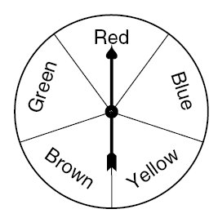
- Find the total number of possible outcomes of spinning the spinner and choosing a number from 1 to 5.

- How many different outfits can you make from 4 T-shirts, 5 pairs of jeans, and 5 pairs of shoes?

____________________________________ consists of two or more events. As with a single event, the probability of a compound event is the ratio of the number of favorable outcomes to the number of possible outcomes.

