Name ___________________________________ Date ____________________________
Lesson #79 –Experimental Probability

Probability that is based on repeated trials of an experiment is called ____________________________.

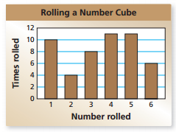
The bar graph shows the results of rolling a number cube 50 times.
- What is the experimental probability of rolling an odd number?

- What is the experimental probability of rolling an even number?

- What is the experimental probability of rolling a number greater than 4?

- What is the experimental probability of rolling a prime number?

- What is the experimental probability of rolling a composite number?

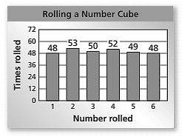
The bar graph shows the results of rolling a number cube 300 times.
- What is the experimental probability of rolling an odd number?

- What is the theoretical probability of rolling an odd number?

- How does the experimental probability compare with the theoretical probability of rolling an odd number?

- What must be done to get the experimental probability closer to the theoretical probability?

- Find the experimental probability of rolling a number greater than 1.

- Find the theoretical probability of rolling a number greater than 1.

- Compare the experimental probability to the theoretical probability of rolling a number greater than 1.

