Name ________________________________________ Date _____________________
Homework # 116 – Graphing a Line Using a Table
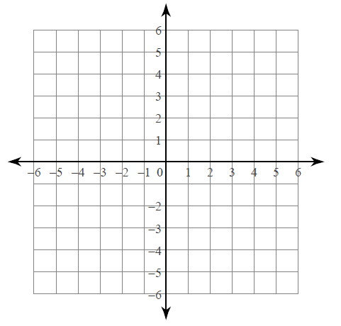
Directions: For each linear equation, complete the table of values and graph.
- y = x + 2

x | y = x + 2 | y
-3
-2
-1
0
1

- y = -x + 1

x | y = -x + 1 | y
-4
-2
0
2
4

- y = -3x – 1

x | y = -3x – 1 | y
-2
-1
0
1
2

- y = ½ x

x | y = ½x | y
-4
-2
0
2
4

