Name __________________________________ Date _________________________

Homework #100 –Using Area and Circumference

Directions: Find the area or circumference of the following circles by using an equation and solving algebraically. Use 3.14 for π. Round answers to the nearest tenth.

- A clock face has a circumference of 39.88 cm. What is the area of the clock?

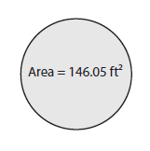
- Find the circumference of the following circle.

- The area of a circular floor carpet is 1243.47 cm². Find the circumference of the floor carpet.

- Find the circumference of the following circle in terms of π.

A= 4π in.²

- The circumference of a circle is 5π cm. Find the measure of the area. Use 3.14 for π.

- The circumference of the frisbee is 14π in. Find the area of the Frisbee.

- Find the perimeter of the following figure to the nearest tenth.

